**CARINYA SCHOOL 5703**

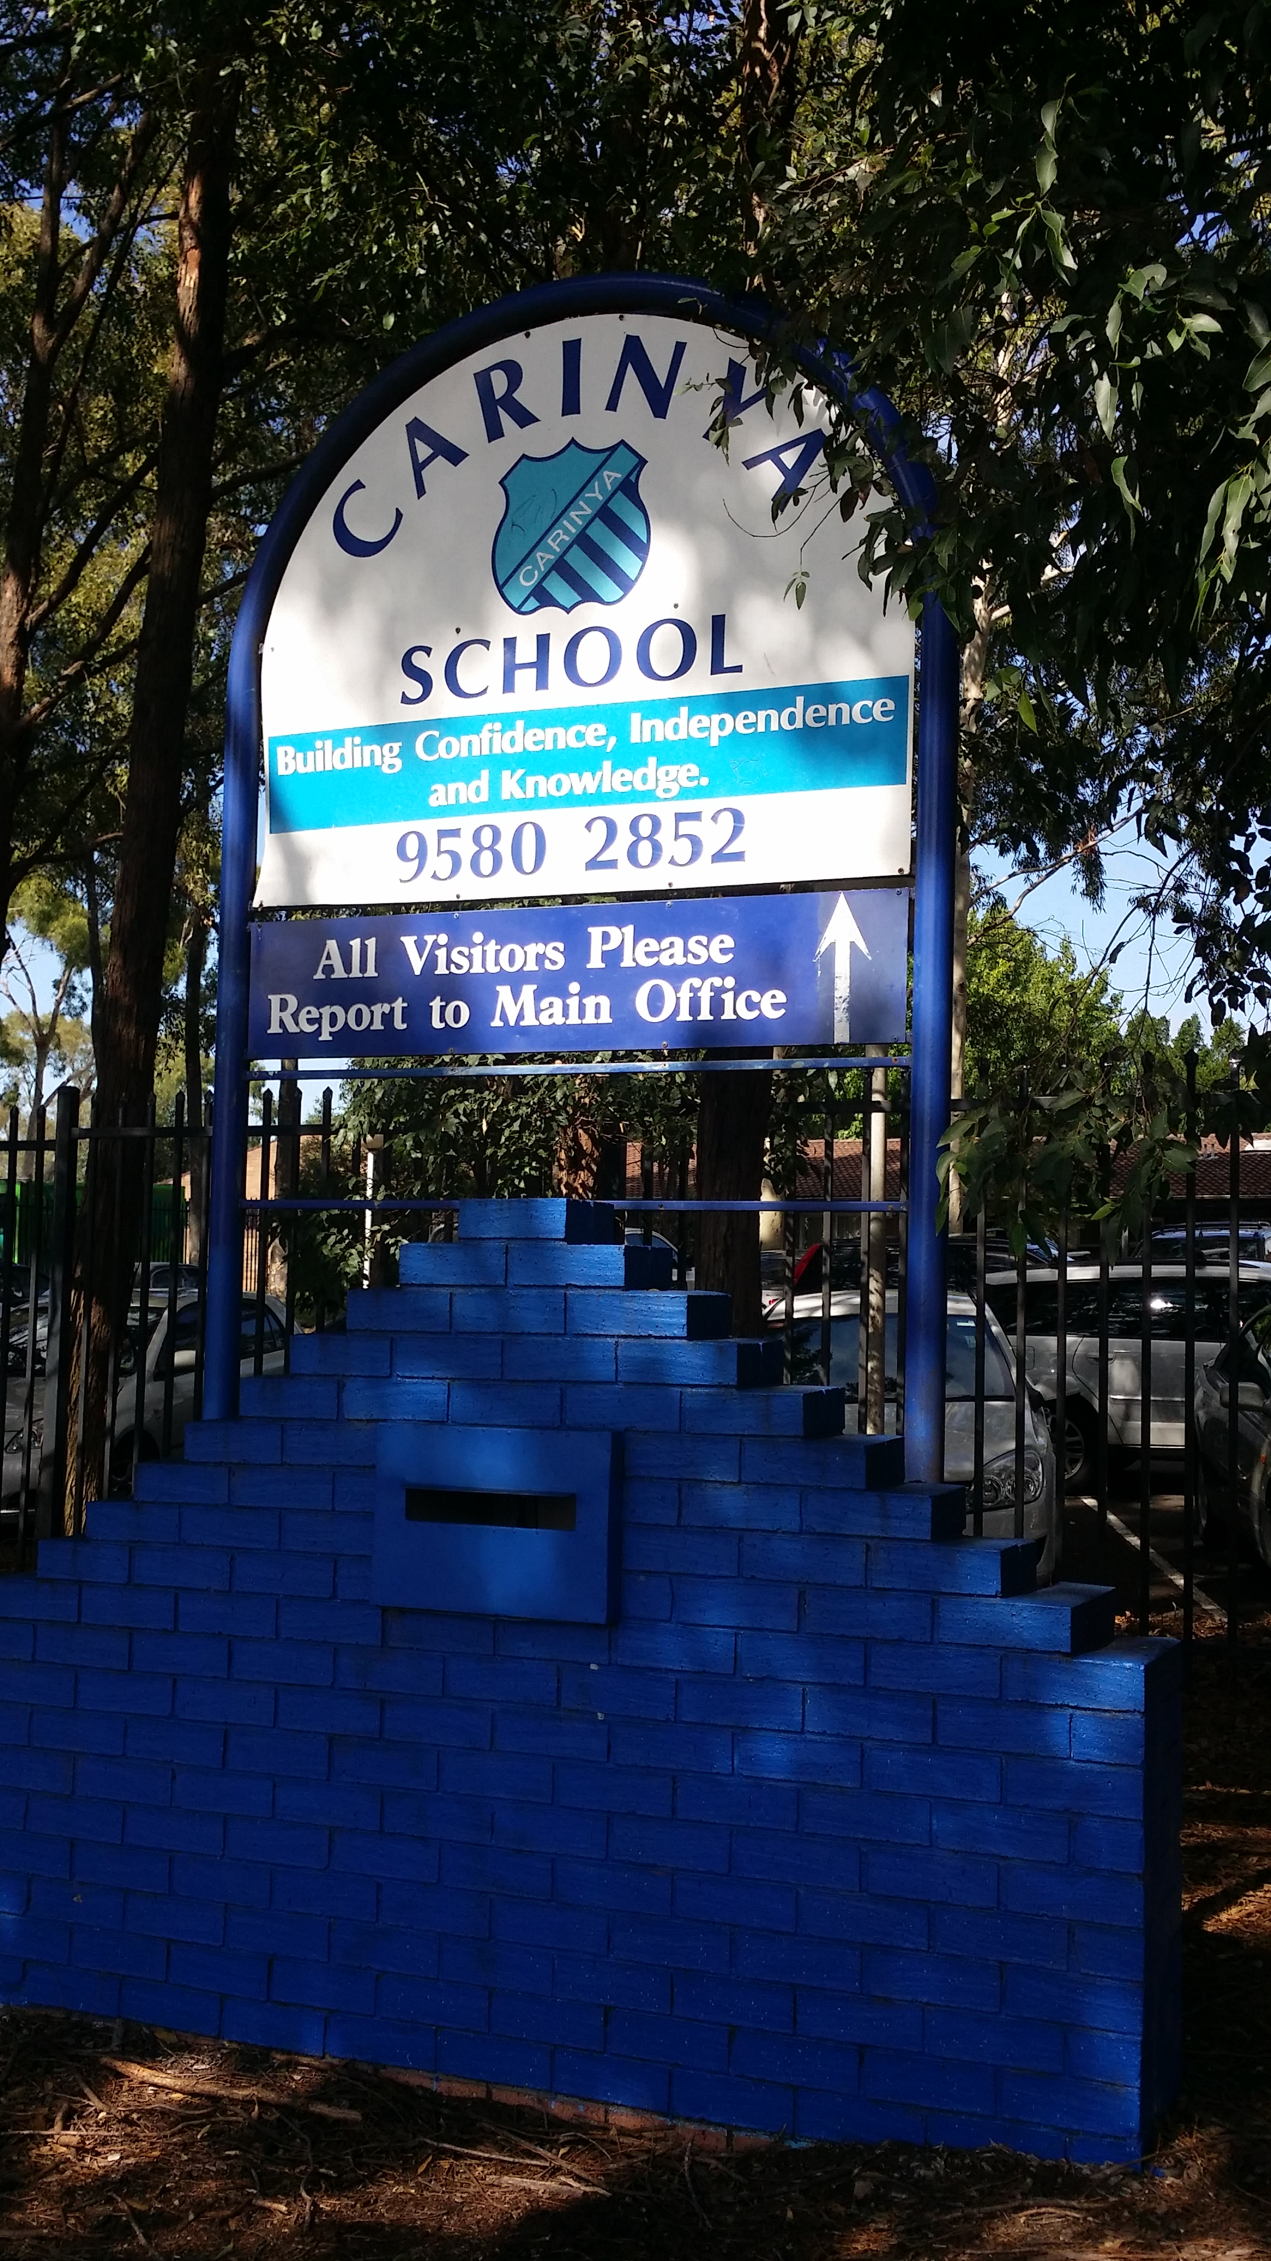

|  |  |  |  |  |
| --- | --- | --- | --- | --- |
|  | | | | |
| **School vision statement** |  | **School context** |  | **School planning process** |
| At Carinya School, every student in our care has the opportunity to achieve their personal best through engaged, active learning, within an inclusive, diverse and safe environment.  Students will develop a sense of self-worth and self-awareness, thus enabling them to better manage their emotional, mental and physical wellbeing. |  | Carinya School for Specific Purposes provides educational programs for students in Years 3 – 12 who are anxious and may have intellectual disabilities, mental health problems and/or autism. The school develops programs tailored to meet the individual needs of students, building their confidence, independence and knowledge. The school encourages students to interact with the wider community through service learning projects such as land care and work experience or job coaching.  Apart from the mandatory courses, the school offers a range of electives designed to provide hands on learning experiences. These include: music, physical activity and sport, and lifestyle and recreational studies. Students are offered regular or life skills outcomes, depending on the individual needs of the students, which are discussed and implemented after meeting with the student and families during Individual Learning Plan meetings.  The focus on each student achieving his or her best academically and vocationally is supported by a strong focus on developing social skills and building student resilience. Programs also promote the development of a healthy lifestyle for students. The school shares facilities such as library, hall and sporting ovals with Mortdale Public School. |  | The School Plan is the result of a rigorous process of whole school communication and collection of data.  Staff, students, parents/carers and Government and non-Government agencies were asked a number of questions. They were asked to identify practices that they felt are successful in the school and then to identify areas for improvement. They were also asked where they would like our school to be in 3 years’ time.  All staff filled out a questionnaire based on the Melbourne Declaration. They were asked how the school was currently meeting the goals in the declaration and what changes could take place to ensure these goals are achieved in future. Specific data from school assessments was collected to analyse for this strategic plan.  This consultative feedback from students, community and staff identified strengths, opportunities and areas of further development for the school Plan 2015 – 2017.  As a result, three key strategic directions were identified as a basis for a shared commitment to future development within the school. These are:   1. Leader/Teacher Learning 2. Student Learning 3. School and Community Learning |
|  |
|  |

|  |  |  |  |  |
| --- | --- | --- | --- | --- |
|  |  |  |  |  |
| **Purpose:**  Teacher and Support staff build workforce capacity through forward professional learning that is sufficiently flexible to meet the diverse and complex needs of our students.  Staff engage in individualised, team and shared professional learning. Leaders and teachers will have high expectations of themselves and their students in order to foster sustained school improvement. |  | **Purpose:**  Every student in our care to be actively engaged in meaningful, challenging and future-focused learning experiences, to promote achievement and foster well-being. |  | **Purpose:**  To inspire a culture of collaboration and communication between families, community members and key stakeholders which lead to improved student outcomes and a deeper sense of pride within the school community. |

|  |  |  |  |  |  |  |
| --- | --- | --- | --- | --- | --- | --- |
| Strategic Direction 1: Leader/Teacher Learning | | | | | | |
|  | | | | | | |
| **Purpose** |  | **People** |  | **Processes** |  | **Products and Practices** |
| **Why do we need this particular strategic direction and why is it important?**  Teacher and Support staff build workforce capacity through forward professional learning that is sufficiently flexible to meet the diverse and complex needs of our students.  Staff engage in individualised, team and shared professional learning. Leaders and teachers will have high expectations of themselves and their students in order to foster sustained school improvement. |  | **How do we develop the capabilities of our people to bring about transformation?**  **Students:** Enable and provide opportunities for our students to become self-motivated and strive to achieve each day.  **Staff:** Build a positive school culture through inspiring and motivating staff to focus on Professional Development that will increase their skills and improve student learning.  **Parents/Carers:** Support a culture of positive partnerships and two-way communication that successfully supports parents’ knowledge and understanding for the benefit of the students.  **Community Partners:** Collaborative approaches with key stakeholders that support the educational, social, emotional and cultural needs of students and families.  **Leaders:** Collaborative planning and consulting with professional learning communities to build their capabilities as learners, teachers and leaders. |  | **How do we do it and how will we know?**   * Supervisors to work with staff to develop their Professional Development Plans * A review of the Quality Teaching model and guidance for teachers to use the model * Students engage in quality learning experiences developed through a strong knowledge of differentiation and high expectations * Teachers given programming support to write quality multi-modal programs based on the Australian Curriculum   **Evaluation Plan**   * Feedback from processes including Instructional Rounds and classroom observations * Evaluate teacher programs, including Individual Learning Plan and Individual Transition Plan goals * Parent, student and staff surveys conducted annually to evaluate level of satisfaction * Feedback from focus teams, analyse student data monitoring their learning and support needs |  | **What is achieved and how do we measure?**  **Products:**   * Staff engage in quality professional development and experience success achieving their professional goals at a rate of 100% * Differentiated learning tasks based on Individual Learning Plans and Individual Transition Plans are used by 100% of teachers * Curriculum planning, programming and assessment practices reflect the Quality Teaching Model and are responsive to student needs * Whole school data shows 100% of Aboriginal students achieving their ILP and ITP goals   **What are our newly embedded practices and how are they integrated and in sync with our purpose?**  **Practices:**   * School leaders place a high priority on the ongoing professional development of staff, where teachers take responsibility to regularly monitor the effectiveness of their own efforts to meet their Professional Development Plan goals. * Clear and consistent expectations and learning experiences that provide consistent opportunities for differentiation * Teaching staff have access to a broad range of student achievement and wellbeing data to inform and develop Quality Teaching programs |
| **Improvement Measures** |  |
| * 100% of staff will have a Performance and Development Plan (PDP) * 100% of teachers developing and delivering differentiated learning tasks that are tailored to meet the needs of students within the school * Supervisors report improved programming with reference to the Quality Teaching Model * 100% of Aboriginal students will meet their Individual Learning and/or Transition Plan goals |  |
| Strategic Direction 2: Student Learning | | | | | | |
|  | | | | | | |
| **Purpose** |  | **People** |  | **Processes** |  | **Products and Practices** |
| **Why do we need this particular strategic direction and why is it important?**  Every student in our care to be actively engaged in meaningful, challenging and future-focused learning experiences, to promote achievement and foster well-being. |  | **How do we develop the capabilities of our people to bring about transformation?**  **Students:** Creating processes and practices that are engaging, differentiated and meaningful and provides opportunities to develop individual strengths and interests, thus promoting ownership of learning. Access to other learning opportunities through school to work programs and TAFE, to provide a real world experience.  **Staff:** Design and implement innovative and engaging learning experiences, which build individual and meaningful relationships with students and community. Professional Learning focusing on Positive Behaviour for Learning, Non Crisis Intervention Training, Instructional Rounds, National Curriculum and research based Mental Health initiatives.  **Parents/Carers:** Communicate the School Plan, develop their knowledge of school processes and provide forums for parental feedback.  **Community Partners:** There will be strong communication networks within and across government and non-government partners as contributors to individual and collective wellbeing.  **Leaders:** Mentor and provide individual support to staff to assist in the development of a consistent and collaborative school learning environment that is accountable and transparent. |  | **How do we do it and how will we know?**   * Learning and Support Team will have rigorous identification and monitoring processes to ensure high levels of support for identified students * Staff are mentored and supported in developing and evaluating ILPs and ITPs, including community consultation, review processes, smart goals and time frames * Staff are mentored to develop their knowledge and capabilities of Positive Behaviour for Learning. Students are provided with supportive frameworks that result in improved performance, and decreases in suspensions. * Staff are mentored and supported in developing relevant and current Risk Management Plans * Use data analysis to identify students for literacy intervention   **Evaluation Plan**   * Surveys and data collation and analysis identifies improvements in students accessing individual programs * Feedback from processes including instructional rounds and classroom observations * Parent, students and staff surveys conducted yearly to evaluate level of satisfaction * PBL and suspension data indicate a decrease in suspensions |  | **What is achieved and how do we measure?**  **Product:**   * 100% of students supported through ILPs and ITPs, will meet their target goals * 100% of staff utilising Positive Behaviour for Learning strategies and procedures, resulting in a 5% decrease in suspensions each year * 70% improvement in reading for students supported through the MiniLit and MultiLit programs * 100% increase in reading levels for Aboriginal students supported through the MiniLit and MultiLit programs   **What are our newly embedded practices and how are they integrated and in sync with our purpose?**  **Practice:**   * Clear and consistent SMART goals that provide opportunities for differentiated learning and individual approaches * Clear and consistent school wide approach to Positive Behaviour for Learning approaches to develop the capacity of staff, community and students * A whole school coordinated approach providing targeted students with an individual intensive reading program |
| **Improvement Measures** |  |
| * 100% of students will meet their ILP and ITP goals * 5% decrease in suspension rates each year * 70% improvement in reading for students accessing MiniLit and MultiLit each year * 100% increase in reading levels for Aboriginal students accessing the MiniLit and MultiLit programs * 100% of staff clearly understand and implement Positive Behaviour for Learning strategies and procedures |  |
| Strategic Direction 3: School and Community Learning | | | | | | |
|  | | | | | | |
| **Purpose** |  | **People** |  | **Processes** |  | **Products and Practices** |
| **Why do we need this particular strategic direction and why is it important?**  To inspire a culture of collaboration and communication between families, community members and key stakeholders which lead to improved student outcomes and a deeper sense of pride within the school community. |  | **How do we develop the capabilities of our people to bring about transformation?**  **Students:** Enrich students’ appreciation of the multi-cultural society in which we live. Students gain and develop leadership skills through involvement in SRC, public speaking, transition programs and cultural events.  **Staff:** Staff supports community empowerment through increased communication and parent feedback forums. Student progress and success is communicated through purposeful two-way communication. A culture of trust, collegiality and collaboration is built to support each other.  **Parents/Carers:** Participate in forums and meetings to actively engage with their child’s learning. Aboriginal and non-Aboriginal community members support the school to close the achievement gap for students from Aboriginal and low socio-economic backgrounds.  **Community Partners:** Work together to establish meaningful and proactive partnerships to engage our students in ‘real world’ activities; including: community access, work experience, TAFE and multi-cultural days.  **Leaders:** Acknowledge and support inclusive teaching practices and collaboration within agencies. Build leadership capacity through succession planning. |  | **How do we do it and how will we know?**   * The school and families work together to develop strategies to use in the home to build students’ strengths * Parent information sessions on a variety of topics * The school works closely with new families to welcome them and to ensure they are fully informed of school policies and procedures * Expand leadership opportunities for staff and students   **Evaluation Plan**   * Survey students, staff and parents/community to evaluate communication and feedback processes across the school * Schools will self-assess student wellbeing in their local context through: ILPs/ITPs and school clinics and surveys |  | **What is achieved and how do we measure?**  **Products:**   * 50% improvement in whole school communication * 20% increase in forum attendance, cultural events and completion of surveys * Teacher/SLSO release time to promote Aboriginal Education programs is increased by 20%   **Practices:**   * Parents are supported to participate in their child’s learning and are partners in their child’s education * Families develop their understanding of learning programs and expected student behaviours, through improved home-school communication * Aboriginal community involvement is an integral part of the school that supports two-way learning, knowledge and understanding for all students, staff and the community * Community views are sought on a regular basis, thus providing an impetus for school planning and programming |
| **Improvement Measures** |  |
| * 50% increase in the satisfaction of parents/carers with the effectiveness of communication between school and home * 20% increase in our home school partnerships, with parents/carers attending school forums, cultural events and completing school surveys * 100% of Aboriginal parents/carers to receive written reports on strategies and programs to improve Aboriginal students’ performance * 20% increase in teacher/SLSO release time to promote Aboriginal Education programs |  |