[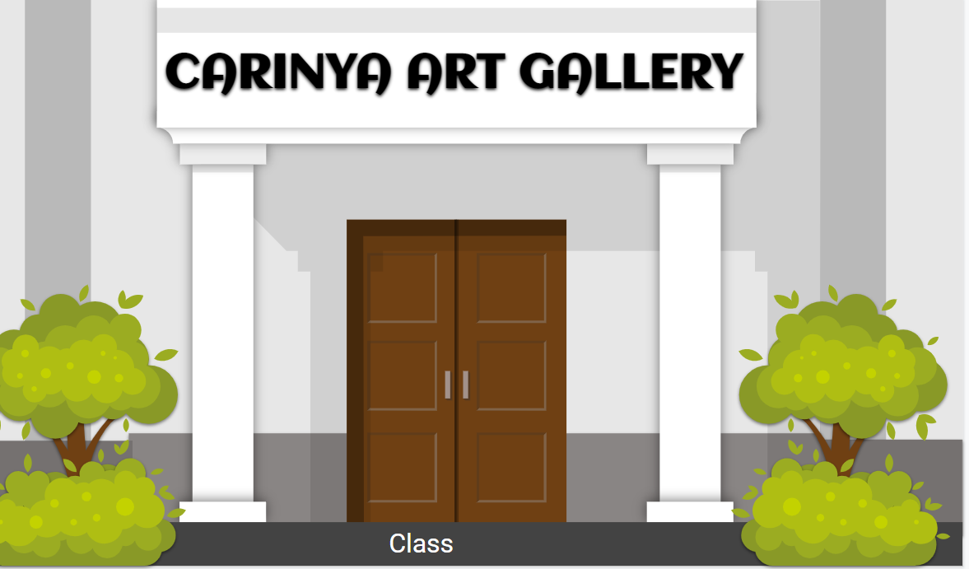Click on picture to access presentation](https://docs.google.com/presentation/d/1ZoBUC_ggezTq0h7C7f7K2cXpGmwVdv0pr-8AJbpvI4c/edit?usp=sharing)